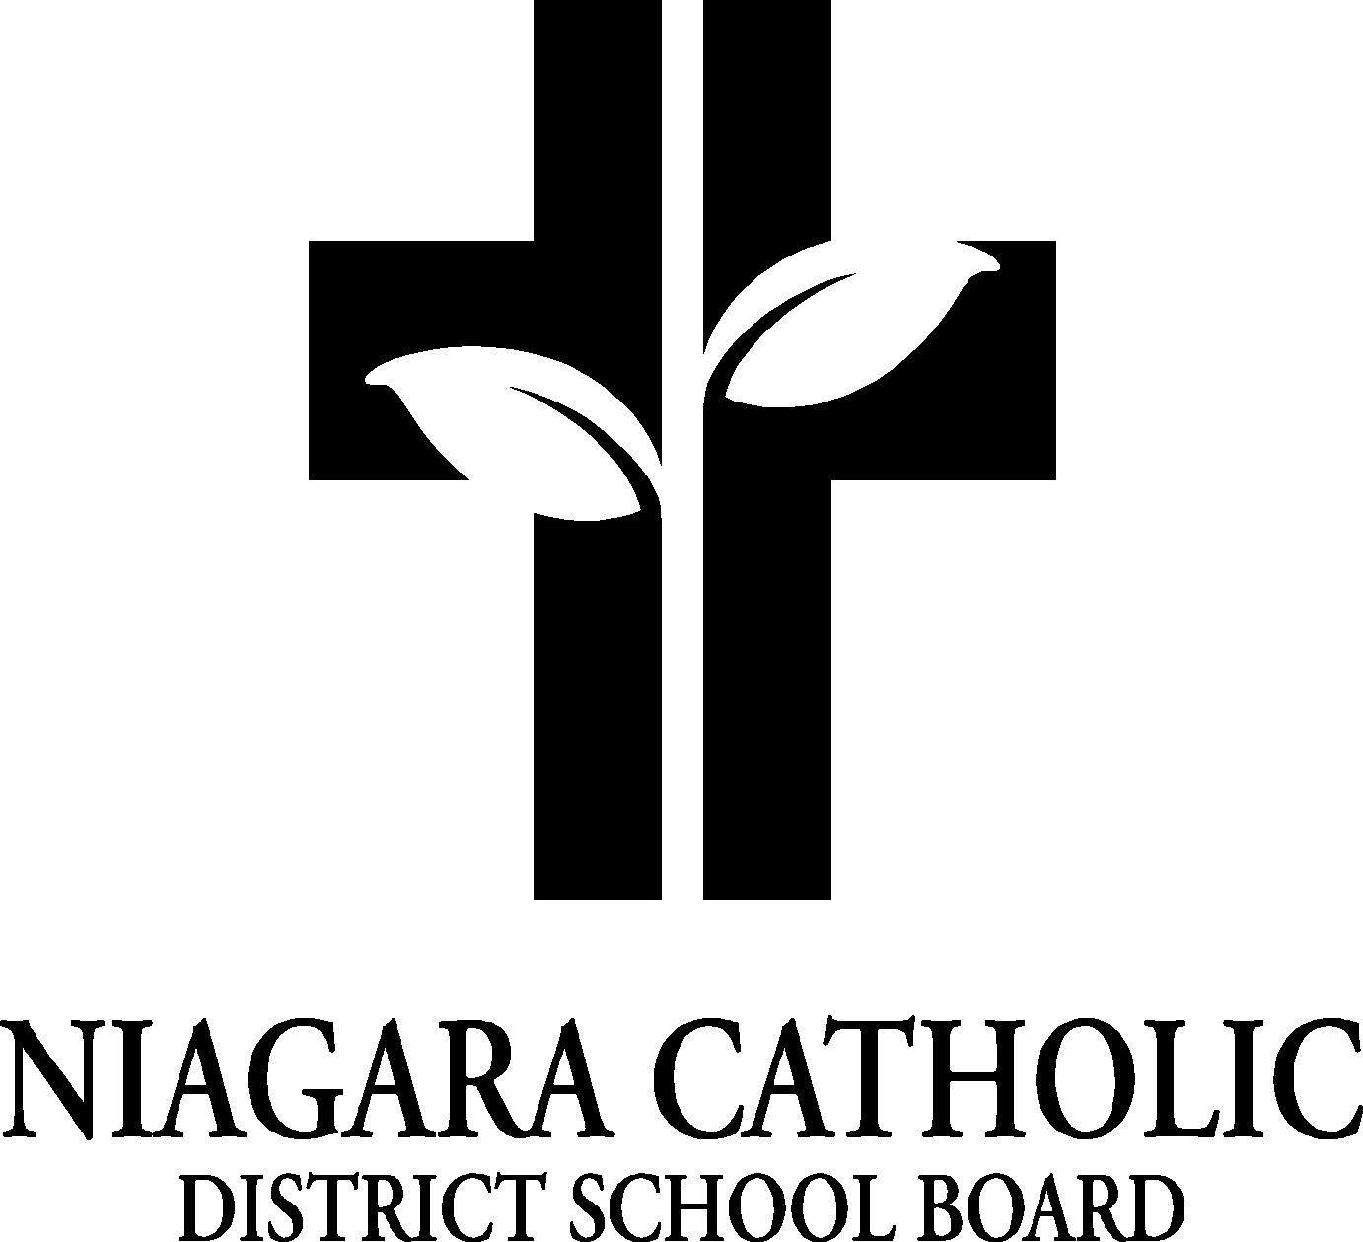

MINUTES OF THE
St. Charles and Monsignor Clancy VIRTUAL CATHOLIC SCHOOL COUNCIL MEETING

April 26th, 2022

Minutes of the Meeting of the St. Charles and Monsignor Clancy Catholic School Councils, held virtually on April 26, 2022, at 6:00pm
The meeting was called to order at 6:06pm by Dan Trainor Principal of Monsignor Clancy.

A. ROUTINE MATTERS

1. Opening Prayer

The opening prayer was led by Mr. Trainor

2. Roll Call

CATHOLIC SCHOOL COUNCIL MEMBERSHIP |  | Present | Excused | Absent
Principal/Vice-Principal  Secretary/Treasurer | Dan Trainor/ Chris Zanuttini | •
Chair | Franca Milan | •
Co-Chair
Teacher Representative | Tanya Masales, | •
Non-Teaching Representative | Lucy Lefebvre/ Debbie Wilsher | •
Student Representative
Parish Representative | Patti McGinnis |  |  | •
OAPCE Representative
PARENT REPRESENTATIVES
Laurie Hebert |  | •
Rosanne French |  |  |  | •
Marci Morandin |  | •
Melissa Desabrais |  |  |  | •
Lana Funk |  |  | •
Mary Kate Skubel |  |  |  | •
Alicia Merry |  |  |  | •
Elizabeth Cicchino |  |  |  | •
Meghan Wilson |  | •
Kendra DeGasparis |  |  |  | •
Ian Woods |  |  |  | •
Jeff Maxwell |  | •
Claire Ellsworth |  |  |  | •
Karine Mahler |  | •
Kieran Daniels |  | •
Angela Coleman |  |  |  | •

3. Approval of the Agenda

Moved by Jeff Maxwell
Seconded by Lucy Lefebrve
THAT the St. Charles and Monsignor Clancy Catholic School Councils approve the Agenda of the St. Charles and Monsignor Clancy Catholic School Councils Meeting of January 26, 2022.
CARRIED

4. Disclosure of Interest

Item F.3 – the following individuals are school board employees – Audrey Weber, Tanya Masales, Jeff Maxwell, Lucy Lefebvre, Laurie Hebert, Rosanne French

5. Approval of Minutes of the Monsignor Clancy Catholic School Council Meeting of January 2
26, 2022
Approved by Laurie Hebert
Seconded by Jeff Maxwell
THAT the St. Charles and Monsignor Clancy Catholic School Councils approve the Minutes of the St. Charles and Monsignor Clancy Catholic School Council Meeting of January 26, 2022.

- PRESENTATIONS
- Policies Being Vetted
The following policies are being vetted:
- NCDSB by-laws policy
Please submit your feedback to Jennifer Pellegrini by May 31st, 2022

- Principal’s Report
- Niagara Catholic Parent Involvement Committee (NCPIC) Report: Mary-Kate Skubel
Mary Kate was not present at the meeting.
Mr. Zanuttini added that the nomination forms are available on the board website. Anyone interested in being a part of NCPIC should fill in an application form.
- Special Education Advisory Committee (SEAC) Report: C. Zanuttini – there is no current report from SEAC. If anything comes up before the end of the school year it will be shared with members of Catholic School Council.
- Catholic School Council Financial Report – nothing to report
- Other Updates- Mr. Zanuttini and Mr. Trainor
  - 2022-2023 school calendar- the draft calendar was shared. However, the approved calendar for the 2022/2023 school calendar is to be announced later.
  - Our Lady of the Holy Rosary construction update- The staff and students at Monsignor Clancy are currently living in Phase 1 of the renovation. Phase 2 was just finished. A deficiency list for phase 1 is currently being worked on. A walk thru will occur with the architect and Bromac to discuss these issues.
Phase 3 – an architect has been assigned. The hope is the work will begin in the next month. This includes the horseshoe, in the original part of the building. Phase 4 is the middle part of the original school and the gym. These will progress as we move forward.
The kinder play area is to be completed over the summer months.
  - Transition visit dates – transition visits between staff and all students will occur. The dates are to be announced. The plan includes students from St. Charles visiting the classrooms at Monsignor Clancy, as well as some community building activities between the 2 schools.
  - Ash Wednesday/Holy Week Mass/Lenten Food Drive updates- We had the good fortune of having a virtual Ash Wednesday mass. Staff spread ashes on the top of the student’s head. We had mass from the St. Charles chapel at Monsignor Clancy during Holy Week. It was a nice end to Holy Week. There was an amazing outpouring of food donations made to St. Vincent de Paul from both school food drives.
~There will be 2 masses during education week for the students at Holy Rosary Church. Weekly masses will begin the following week in the St. Charles chapel. If protocols permit, Father would like to come into the younger grades in their classes to do more teaching with the younger students.
  - NCDSB/Diocesan Synod session – Synod sessions were occurring in parishes. It was an opportunity to have open conversations as people of the church and how we can connect back to our parishes and what we need to move forward. Information from these sessions will be shared with Pope Francis.
  - Legacy Hoodies- Legacy Hoodies are currently in the planning phase. Prices and quotes take time. As soon as Franca has this information, she will share with Catholic School Council. Prices seem to be higher than what was talked about last year.
. The expected price for a hoodie should be between $22 – $30.
  - EQAO status – EQAO has changed its format. This year the assessment will be digital. There has been some staff training. Grade 6 testing will be in mid June. They have given a longer amount of time to administer the assessment. St. Charles is looking at the same dates to administer the assessment. St. Charles also has new chrome books to be used. The writing time for this years EQAO is shorter than years past
  - FDK Open House @ OLHR – There are currently 43 registrants for year 1 kinder for September 2022. There is a plan to have an open house for the Kinder students. The plan is for the open house to be an in-person event (if protocols permit). Mr. Zanuttini and Mr. Trainor have a powerpoint to share with families. Franca Milan was asked if she is available to attend to represent the Catholic School Council. The tentative plan is to host the open house the week following the May long weekend.
End of Year excursions – End of the year excursions are currently in the planning stage and being booked. More information will be shared with families as it becomes available/ confirmed. The Kinders and Grade 1 – both grades are going to the Safety Village. The Grade 2 and 3’s will be attending the PALS program at Brock. The Grade 4 and 5’s are planning a day at Queenston Heights and to see the Descendants musical. The Grade 6 and 7’s will be going to Wild Play in Niagara Falls. The Grade 8 will be going on a 2-day trip to Blue Mountain.
~question was raised about parent volunteers – Mr. Trainor mentioned about the additional police checks.

- OAPCE REPORTS – no update

- STAFF REPORTS
- Hot Lunches -food program is going well
- Pita Pit – they are offering a fruit juice or smoothie. Should we proceed. It was decided to look at this for next year.

- Agenda Items for Future meetings – nothing

- NEXT MEETING – September 2022

Mr. Trainor gave a heart felt thank you to the community about his time here in Thorold. He is honoured for the time given. He talked of the changes to the school for the safety and well being of the school. Mr. Zanuttini thanked Mr. Trainor for his commitment to the community.

- ADJOURNMENT
Moved by Jeff Maxwell
Seconded by Laurie Hebert
THAT the April 26th, 2022 meeting of the St. Charles and Monsignor Clancy Catholic School Councils be adjourned.

This meeting was adjourned at 6:35 PM.

- CLOSING PRAYER was led by Mr. Zanuttini

